Hong Kong College of Nursing and Health Care Management

Nursing and Health Care Management Fellowship Programme

Clinical Logbook

(Version 2)

(Revised in May 2021)

Nursing and Health Care Management Fellowship Programme
Clinical Logbook

Name of Candidates | :
Position & Workplace | :
Intake Year | :
Candidate No. | :
Mentor | :
Training Site | :

Content Page

Part A. The Big Picture …………………………………………………………………………………………………… P.4
- When to use the Logbook ………………………………………………………………………………………… P.4 - P.5
- How to use the Logbook …………………………………………………………………………………………………… P.5
- Using the reflective learning model ……………………………………………………………………………....... P.6
- Reflective writing …………………………………………………………………………………………………………….. P.6
- Reflective learning process ………………………………………………………………………………………………. P.6
- Learning activities ……………………………………………………………………………………………………………. P.7
- Documentation of clinical experience ……………………………………………………………………………… P.7- P.8
- Responsibilities of Fellowship Candidates and Mentors ………………………………………………….. P.8- P.9

Part B. Nursing and Health Care Management Fellowship Programme - Clinical Logbook
Reflective learning report on 7 domains
- To provide nursing leadership in managing clients with complex health condition
Learning activities record …………………………………………………………………………………. P.10
- To enhance therapeutic nurse-client relationship ……………………………………………. P.11
- To perform effective leadership in teamwork building …………………………………….. P.12- P.16
- To lead Quality Management / Improvement ………………………………………………….. P.17- P.20
- To implement best practice in managing, and negotiating an innovative and
strategic approaches to care delivery……………………………………………………………….. P.21
- To enhance the development of professional attributes of general and advanced
practice ……………………………………………………………………………………………………………. P.22
- To embrace personal attributes in commitment and responsibility in learning .. P.23

Part C. Learning Activities Record
- Papers published …………………………………………………………………………………………………………….. P.24
- Course, lectures, presentations delivered ……………………………………………………………………….. P.25
- CNE courses, seminars attended …………………………………………………………………………………….. P.26
- Other training activities ………………………………………………………………………………………………….. P.27
- Case record …………………………………………………………………………………………………………………….. P.28
- Mentor’s comment and verification ……………………………………………………………………………….. P.29

Appendix A - Action learning record ………………………………………………………………………………………. P.30- P.31
References ……………………………………………………………………………………………………………………………… P.32
Part A. The Big Picture

Nursing profession is changing continually to accommodate the healthcare demands and patient’s needs. New Facts are emerging and new diseases are appearing, the nursing and health care environment have become a complex place for professional learning. Indeed, greater specialization and fragmentation of services reveal that it is more difficult for nurses to gain a broader managerial experience in clinical settings. Nowadays, the specialization competencies, in particular, are required to be monitored and regulated. Nurses should be competent to care, treat and manage patients in regulated standard requirements. The global trend in nursing and health care management has indicated a strong linkage between education and health care outcomes. Thus, the development of health care management mentoring along with hands on practice are crucial for improvement in the health care system.

The old saying “see one, do one, teach one” is of a bygone era in time of transdisciplinary model of care, specialization and reflective leaning practice. Nurses do have different learning styles. Majority of them find the hands-on practicing are challenging especially in leadership and managing skills. Viewing a competent nursing professional is an ever changing person with personal growth that is marked by a degree of disorganization followed by reorganization of knowing, and mentorship is a requisite in the professional development. Fellowship candidates are motivated to practice through watching mentors and others. It is anticipated that they will embrace the learning and sharing in their professional development.

When a fellowship candidate progresses in his/her learning, the learning environment should provide expert knowledge related to basic and complex clinical decision skill and a level of practice in the related specialty. Observation, interaction and thinking with reflective learning approach are considered valuable learning momentum to become a competent managerial practitioner.

- When to use the Logbook
This logbook is intended to serve as a record of the assessment on the competencies. The reflective writing is a form of personal responses to experience, situation, event or new information where thinking and learning take place. Thus, it reflects the related knowledge and skills acquired. Real time in recording by mentor is essential when the candidate is able to understand, describe and perform a particular procedure after mentoring with evaluation.

This mentoring program is designed to facilitate the learner towards the objective’s achievement. The core competencies are defined by the College based on the learning objectives related to 7 domains. The HKCNHCM and mentors assist candidate in defining the learning objectives and implementing achievable goals.

Each candidate should be able to achieve the core competencies set by the College according to the following 7 domains.

- Domain 1: To provide nursing leadership in managing clients with complex health condition.
- Domain 2: To enhance therapeutic nurse-client relationship.
- Domain 3: To perform effective leadership in teamwork building.
- Domain 4: To lead quality management and improvement.
- Domain 5: To implement best practice in managing, and negotiating an innovative and strategic
approaches to care delivery.
- Domain 6: To enhance the development of professional attributes of general and advanced practice.
- Domain 7: To embrace personal attributes in commitment and responsibility in learning.

The fellowship candidate is required to learn and apply the domain learning objectives and practice by ongoing reflective approach strategically, tactically and operationally. This learning focuses to solve the problem efficiently and effectively. Skills competencies are recorded by confirming the attendance in observation, briefing talks, return demonstration, and assignments on reflective journal and evaluation feedback. The logbook documentation should be appraised by the mentor regularly. Learners should ensure the learning objectives and activities in the logbook to be signed in an updated record. They are encouraged to formulate learning goals, develop plans and reflective actions in documentation. When the learning requirements are fulfilled, the candidate is requested to sign the declaration.

- How to use the Logbook

Fellowship candidate’s learning involves a variety of encounters. These include such as Case Note Review (CNR), Case based Discussion (CBD), and Case Report (CR). CNR is a review of case notes relating to a particular condition and its management. CBD is a discussion using a subordinate or a group as an example of a particular condition. CR is a work-based report emphasizing on one or more aspects of the situational experience which includes assessment, diagnosis, investigation, management and evaluation. There may be also involve complex communication, legal issues or ethical dilemma.

Candidates are encouraged to write up CNRs, CBs, and CRs on a structured format which is aimed to direct them to reflective thinking. The encounter can be summarized in 300-400 words as reflective journal is an opportunity for learners to gain self-knowledge that makes meaning out what is learned. This reflective journal writing is an approach used to solve the real clinical situation or management problem. With this learning, learners can improve the problem-solving skills involving actions and reflecting upon the clinical outcomes. Consequently, through reflective practice participation, mentor promotes and facilitates this reflective learning process that helps learners become an active, conscious and critical learner.

Candidates should prepare their own records which demonstrate fulfillment of the required core competencies. Entries to the Logbook is required to include actual work achieved and supported by relevant documentation such as presentations, board/committee/conference papers, memos, circulars etc. Candidates are requested to complete documents/writing to demonstrate reflective learning based on the core competencies based on seven domains. Besides, they are invited to have regular review to reframe and update the study process including observing, reviewing, and seeking advices. These documents are necessities in the final report. In addition, the candidate can explore different aspects related management practice, such as team functioning, communication and operation, handling conflict, risks and disaster management, stress management, coping relationship, interactions, resources, technology, economy and finance issues. These skills vary in complexity and must be performed competently and can be learnt through clinical observation, education and practice.

This logbook includes learning documentation, in particular, reflective learning writing is designed to learn from experiences which contains both “reflect forward” to the future and “reflect back” on the past. The reflective writing serves to add real life and authenticity to learning. Through exploration, critical analysis and scenario study, these allow to practice reflective thinking and generate new insights and innovations.

- Using the Reflective Learning Model

Dewey (1933) viewed reflection or reflective thinking as experiential learning technique and is seen as problem solving. Reflective thinking generally addresses practical problems, allowing for doubt and perplexity before possible solution are reached (Hatton and Smith, 1995). Learners are guided to explore the concept of reflection and its application within the framework that facilitates critical levels of reflection.

Reflective steps are as follows:
- Identify a real clinical situation or management problem/description;
- Devise a plan and team;
- Apply reflective discussion and learning;
- Explore discussion into measures or actions to tackle situation or problem;
- Commit to reflective learning/improvement goals in problem solving process.

- Reflective writing

Reflective writing is an activity that includes description (what, when, who) and analysis (how, why, what, if). It is a personal response to experience, situations, events or new information where thinking and learning take place.

- Reflective Learning Process

A reflective learning process is to review on experience of practice in order to describe, analyze, evaluate and so inform learning about achieved practice improvement (Reid, 1995). A model of Gibbs’ Reflective Cycle is shown below:

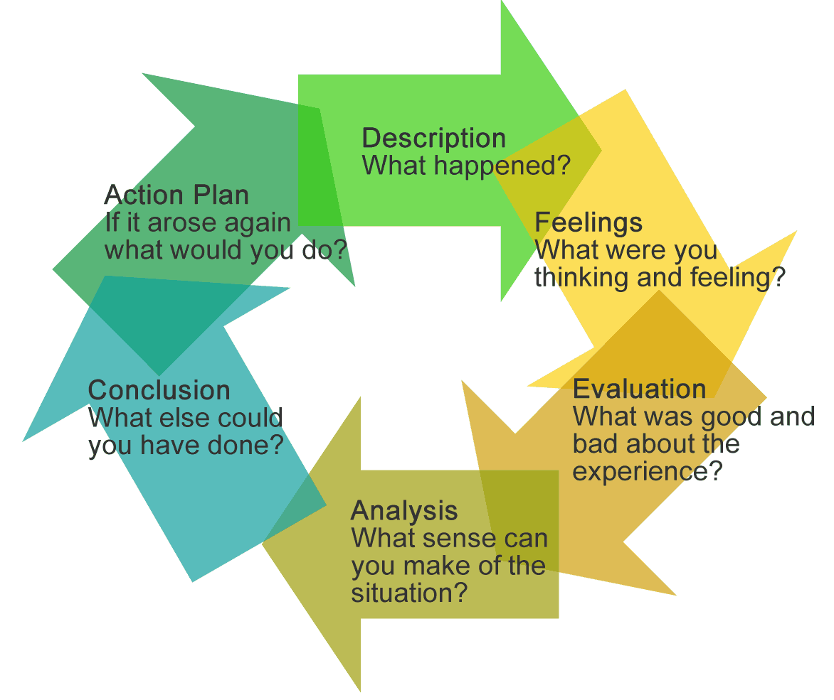

Gibbs’ Reflective Cycle

- Learning Activities

Fellowship candidate’s learning involves a variety of different encounters. He/she can equip his/her competencies though different learning activities, such as:

- Management experience in different situations.
- Case Note Review (CNR) is a review of case notes relating to a particular condition and its management.
- Case Based Discussion (CBD) is a discussion using a subordinate or a group as an example of a particular condition.
- Case Report (CR) is a work-based report emphasizing one or more aspects of the situational experience which includes assessment and diagnosis, investigation, and management. There are other aspects such as a complex communication or ethical dilemma.

Fellowship candidate are encouraged to write up action learning records/reports (Appendix 1) in the format of CNRs, CBDs, and CRs. The action learning is facilitated by the reflective thinking and learning. Each core competency report is limited to 300-400 words and is required to write on each of total 7 domains (attachments in Appendix A). Mentor is required to provide feedback on each reflective learning domain report. At the end of mentoring period, mentor will sign on the Clinical Logbook to verify the learning activities of the fellow candidate.

- Documentation of Clinical Experience

The candidates are required to fulfill the following hours of guided clinical learning and accomplish it within a required time frame.

- Requirement to obtain Ordinary Members:
- Complete 250 hours of initial guided clinical practice at any clinical practice site recognized by the related Academy College;
- Achieve an accumulated 4 years of experience working in the specialty in recent 6 years.

Guided clinical practice includes:
  - Experiential learning with mentor guidance at local clinical specialty departments;
  - Practicum at work/non-workplaces with mentors from local clinical specialty departments under university/tertiary institution programs

- Requirement to obtain Fellow Members:
  - Complete additional 250 hours of final guided clinical practice;
  - Achieve an accumulated 5 years of experience working in the specialty in recent 7 years.

Fellowship candidates should also prepare their own records to demonstrate the fulfillment of the required core competencies. Entries to the Clinical Logbook should enlist actual work done by the learners and prepared with relevant documentation such as reports, presentations, board/ committee papers, memos, and circulars. The copies of documents should be filed in the appropriate core competency section of personal Clinical Logbook. Learners are also required to complete logbook documents / writing to demonstrate their reflections on learning, improvement and development related to the core competencies within 7 domains.

Learners are cordially invited to review and refine with clinical supervisors/ mentors from time to time for reporting and updating the study processes. They will learn the understanding and meaning of quality management through observing, reviewing, evaluation feedback and advices. This ongoing learning reports are necessities for the Clinical Logbook and final report.
Besides, learners will see other aspects of clinical related management practice comprising team functioning, conflict, stress and coping management, relationship, interaction, resources, technology, economy, finance, fiscal, risks and disasters issues.

The core competency assessment is a cumulative exercise over the entire mentoring period. The final assessment of learners will examine on their achievement on core competencies documented on individual Clinical Logbook and reflection reports.

In sum, the mentoring relationships will progress and change, and be connected. The reflective strategy should focus from routinely doing to a development of an ability to look critically at practice by raising consciousness, and perspective transformation. Framing and reframing to know what learners have learned are critical as this transitioning takes time. The transitioning involves:

- Evaluating the process.
- Providing positive feedback on learner’s accomplishments.
- Acknowledging the learning.
- Discussing the future options or improvements.

- Responsibilities of Fellowship Candidates and Mentors

- Responsibilities of Fellowship Candidates:

- Are responsible to make the first contact with his/her mentor.
- Take initiatives in identifying and meeting learning needs.
- Is capable to ask for help or advice and to tackle challenging clinical management situations.
- Seek guidance and support from mentor whenever necessary and decide upon the amount of help and guidance he/she needs.
- Utilize available resources to increase knowledge base.
- Is able to reflect on the new learning, insights in the professional development by demonstrating actions with compliance and commitments.
- Should keep every record of the learning activities or experience on the issued logbook, and can be summarized in the format such as Case Note Review (CNR), or Case Based Discussion (CBD) or Case Report (CR)
- Is capable to demonstrate the solving real clinical situations or management problems by action learning process.
- Evaluate effectiveness of clinical learning and provide feedback or sharing to mentor.
- Should be responsible for keeping accurate and timely record on a regular basis.
- Should keep data privacy on all documentations, patients are respected for confidentiality, and no patient’s identifiers are found in the logbook.
- Is able to discuss personal responses to experience where reflective thinking and learning take place with documentation in the Clinical Logbook with mentor at regular intervals. The reflective writing and record must be signed by the mentor.
- Should complete the Clinical Logbook.

- Responsibilities of Mentors:

- Are responsible to guide the fellowship candidate to prepare the fellowship program.
- Facilitate learners to participate in managing hospital or department project.
- Help identify problems and guide learners towards solutions.
- Provide guidance based on learners’ experience. Guidance should lead directly from the stated concerns of them.
- Set goals and plans to meet learning needs.
- Capable to help in developing reflective writing and presentation skills.
- Facilitate to map the learning opportunities with competencies framework.
- Lead and empower learners through problem solving processes. Work through problems with them.
- Assist learners to identify opportunities to develop the leadership abilities and leading the team.
- Feedback on the action learning process and report.
- Meet regularly with learners and provide evaluation feedback on learning.
- Facilitate to complete the Clinical Logbook.
- Verify and sign the Clinical Logbook.
- Should neither be a mentee nor a mentor of more than 2 specialties at the same time.

Part B. Nursing and Health Care Management Fellowship Programme - Clinical Logbook

Reflective Learning Report on 7 Domains
Domain 1: To provide nursing leadership in managing clients with complex health condition.

Learning Experience/ Problem Identification | Intervention Skills/ Plans /Strategies | Enabling Outcome |  |  | Reflective Context
 |  | CNR | CBD | CR | Opportunities/  Challenges | Achieved | Improvement
Managing complex case individually

Reflective Learning:

Feedback / Evaluation:

Domain 2: To enhance therapeutic nurse-client relationship
Learning Experience/ Problem Identification | Intervention Skills/ Plans /Strategies | Enabling Outcome |  |  | Reflective Context
 |  | CNR | CBD | CR | Opportunities/  Challenges | Achieved | Improvement
Lead health promotion program
Provide Patient education on _____
Reflective Learning:

Feedback / Evaluation:

Domain 3: To perform effective leadership in teamwork building
Learning Experience/ Problem Identification | Intervention Skills/ Plans /Strategies | Enabling Outcome |  |  | Reflective Context
 |  | CNR | CBD | CR | Opportunities/  Challenges | Achieved | Improvement
Operational Management
Staff supervision

Manpower planning & skills mixed matching

Bed & Overflow management

Preparation of equipment and supplies for unit/ department

Equipment Management
Requesting, transferring, condemnation, repair and maintenance of medical equipment/ furniture
Loaning and borrowing equipment between wards and departments

Application for trial of new medical devices

Handling of CSSD items

Learning Experience/ Problem Identification | Intervention Skills/ Plans /Strategies | Enabling Outcome |  |  | Reflective Context
 |  | CNR | CBD | CR | Opportunities/  Challenges | Achieved | Improvement
Complaint Management
Immediate Handling
Investigation

Improvement and preventive measures

Reply to complainant
Staff debriefing
Handling of Appreciation
Media Handling

Emergency Response on call arrangement-

Resuscitation

Preparation of Periodic inspection or accreditation visit: Labor Department of Health, JCI, ACHS, OSH, ISO

Learning Experience/ Problem Identification | Intervention Skills/ Plans /Strategies | Enabling Outcome |  |  | Reflective Context
 |  | CNR | CBD | CR | Opportunities/  Challenges | Achieved | Improvement
Resources Management
Organizational and
Hospital Vision, Mission and Objectives
Corporate Governance:
- Nursing Services Policies
- Patient Care Policies
- Organization Chart
Annual budget

Human Resource Management
Duty planning:
- Planning of duty roster (including annual leave) for nursing/supporting personnel
- Handling of sick leave and staff on injury (IOD)
Performance appraisal:
- Preparation of Annual Appraisal Report
- Conduct periodic Interview Performance management
- Counseling
- Performance Improvement program for under-performed staff

Learning Experience/ Problem Identification | Intervention Skills/ Plans /Strategies | Enabling Outcome |  |  | Reflective Context
 |  | CNR | CBD | CR | Opportunities/  Challenges | Achieved | Improvement
- Issuance of warning/ disciplinary actions
Recruitment planning:
- Vacancy notification/ advertisement
- Shortlisting
- Interview board
- Promotion
Preparation of job description for any one category of Nursing/ Supporting Personnel
Developing workforce requirement for unit/ department/ hospital

Staff training & development:
- Conduct teaching program for nursing/ supporting staff/ student
- Organization of annual training program for nurses for unit/ department/ hospital
- Organization of a staff development program/ CNE courses Code of Conduct and discipline for all staff

Learning Experience/ Problem Identification | Intervention Skills/ Plans /Strategies | Enabling Outcome |  |  | Reflective Context
 |  | CNR | CBD | CR | Opportunities/  Challenges | Achieved | Improvement
Management of Change
- Lead quality improvement projects
- Participation in service development project

- Lead & implement change on __________
Reflective Learning:

Feedback / Evaluation

Domain 4: To lead Quality Management/Improvement.
Learning Experience/ Problem Identification | Intervention Skills/ Plans /Strategies | Enabling Outcome |  |  | Reflective Context
 |  | CNR | CBD | CR | Opportunities/  Challenges | Achieved | Improvement
Quality and Safety
- Developing/ review guidelines & standards for patients care

Using problem solving approach to identify the problems of unit/ department and develop plan of action
Preparation/ review the plan for disaster management / Drills:
- Fire /electricity failure / bomb threat
- Medical gas supply failure/leakage
- Water supply failure/leakage
Mass Casualty

Infectious Disease Outbreak

Learning Experience/ Problem Identification | Intervention Skills/ Plans /Strategies | Enabling Outcome |  |  | Reflective Context
 |  | CNR | CBD | CR | Opportunities/  Challenges | Achieved | Improvement
Participation in a crisis management scenario:
- Coroner case
- Still birth
- Suicidal case
- Violent case
- Chemical Spills
- Radiation leakage
- Hospital Information System down
- Phone Outage
- Lift breakdown with trapped passengers
- Bomb Threat
Incidents/accidents management:
- Formation of review panel
- Investigation improvement & preventive measures
- Investigation report

Preparedness for Emergency Response:
- Typhoon /Black Rainstorm

Learning Experience/ Problem Identification | Intervention Skills/ Plans /Strategies | Enabling Outcome |  |  | Reflective Context
 |  | CNR | CBD | CR | Opportunities/  Challenges | Achieved | Improvement
Patient safety measures:
- Falls
- Suicide
- Missing
- Handling of Sharps Injury
- Handling of Medical & Nursing Records Confidentiality of Patient Personal Data Lost & found medical records
- Missing
- Wrong reports: XRs, films, Laboratory reports
Management of medication safety:
- Ward stocks
- Dangerous & High Alert drugs
- Patient’s own medicines

Management of Infectious Diseases:
- TB
- SARS
- MERS

Learning Experience/ Problem Identification | Intervention Skills/ Plans /Strategies | Enabling Outcome |  |  | Enabling Outcome
 |  | CNR | CNR | CNR | Opportunities/  Challenges | Achieved | Improvement
Enhance security:
- Prevention of thefts & losses
- Patient found missing
- Child abduction

Project management & planning
- Participation in quality improvement project
- Participation in an evidence-based nursing project
- Participation in clinical/ nursing research
Reflective Learning:

Feedback / Evaluation:

Domain 5: To implement best practice in managing, and negotiating an innovative and strategic approaches to care delivery.
Learning Experience/ Problem Identification | Intervention Skills/ Plans /Strategies | Enabling Outcome |  |  | Reflective Context
 |  | CNR | CBD | CR | Opportunities/  Challenges | Achieved | Improvement
Strategic Management
Study and discuss on:
- Health policy & strategy
- Study on the Hospital Strategic plan
- Participation in hospital annual planning
Reflective Learning:

Feedback / Evaluation

Domain 6: To enhance the development of professional attributes of general and advanced practice.
Learning Experience/ Problem Identification | Intervention Skills/ Plans /Strategies | Enabling Outcome |  |  | Reflective Context
 |  | CNR | CBD | CR | Opportunities/  Challenges | Achieved | Improvement
Present or contribute to Nursing Forum, Conference and Seminar
Publish article / study in ______________________
Contribute in ___________ program
Reflective Learning:

Feedback / Evaluation

Domain 7: To embrace personal attributes in commitment and responsibility in learning.
Learning Experience/ Problem Identification | Intervention Skills/ Plans /Strategies | Enabling Outcome |  |  | Reflective Context
 |  | CNR | CBD | CR | Opportunities/  Challenges | Achieved | Improvement
Reflective Learning:

Feedback / Evaluation

Signature of the Fellowship candidate: |  | Date:
Signature of the Mentor: |  | Date:

*Attach your Case Note Review (CNR), Case based Discussion (CBD), and Case Report (CR) for each item you have experienced

Learning Activities Record
- Papers Published
Title of the Article | Author(s) | Journal / Publication  (Please provide volume/issue numbers, URL and/or do if applicable)
Note: Attach an abstract of the published paper(s)
Signature of the Fellowship candidate: |  | Date:
Signature of the Mentor: |  | Date:
- Courses, Lectures, Presentations Delivered
Date (dd/mm/yy) | Name of the Course/Lecture/Presentation/Event | Organizer | CNE (if any)

Signature of the Fellowship candidate: |  | Date:
Signature of the Mentor: |  | Date:
CNE Courses, Seminars Attended
Date (dd/mm/yy) | Name of the Course/Lecture/Presentation/Event | Organizer | CNE (if any)

Signature of the Fellowship candidate: |  | Date:
Signature of the Mentor: |  | Date:

- Other Training Activities
Date (dd/mm/yy) | Name of the Course/Lecture/Presentation/Event |  |  | Organizer |  |  | CNE (if any)
Signature of the Fellowship candidate: |  |  | Date:
Signature of the Mentor: |  |  | Date:

- Case Record
Case Summary (For supplementing information, please add additional sheets if necessary)
Mentor’s Comment:
Signature of the Fellowship candidate: |  | Date:
Signature of the Mentor: |  | Date:
- Mentor’s Comment and Verification

Mentor’s Comments (please add additional sheets if necessary)

Verification

This is to verify that _____________________________ (Name of fellowship candidate) of HKCNHCM membership number _______________ has completed the period of supervised practice from ____________ (dd/mm/yy) to _____________ (dd/mm/yy).

Signature of the Fellowship candidate: |  | Date:
Signature of the Mentor: |  | Date:

Appendix A - Action Learning Record
Nursing and Health Care Management Fellowship Programme
Action Learning Record

Problem identified:
1. Understanding and Reframing the Problem

2. Framing and Formulating the Goal

3. Developing and Testing Strategies

4. Acting and Reflecting on the Action

Signature of the Fellowship candidate: |  | Date:
Signature of the Mentor: |  | Date:

References

Dewey, J. (1933). How we think: a restatement of the relations of reflective thinking to the educative process. Boston: D.C. Heath & Co.

Hatton, N., & Smith, D. (1995). Reflection in teacher education: Towards definition and implementation. Teaching and Teacher Education, 11(1), 33–49.

Reid, J. M. (1995). Learning styles in the ESL/EFL classroom. Florence, KY: Heinle & Heinle Publishers.

End of Clinical Logbook

